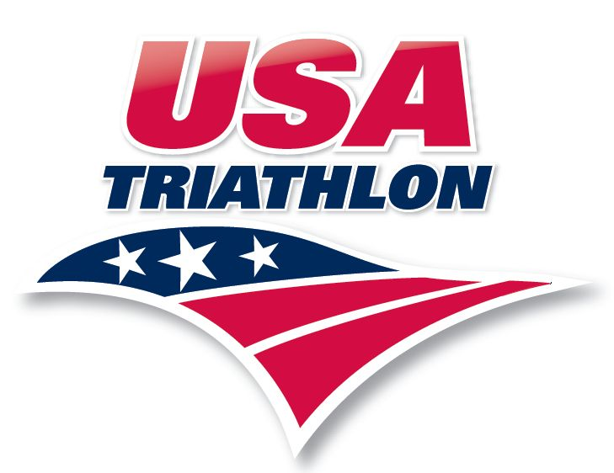
COLLEGIATE COMMITTEE

Governance and Responsibilities of the
Collegiate Committee

AND

Collegiate Club Competitive Rules

USAT Collegiate Triathlon
Web site: http://www.usatriathlon.org/

Edited by the Collegiate Committee of USA Triathlon
© Copyright 2013
USAT Collegiate Triathlon
All Rights Reserved.
Updated October 2015

Mission. The Collegiate Committee (CC) of USA Triathlon (USAT) works to develop, advance, and promote club level collegiate triathlon. The CC shall encourage competitive excellence and shall provide leadership regionally and nationally in order to foster the continued growth of collegiate triathlon throughout the country.

Roles, Responsibility, and Authority. The Collegiate Committee is the working group of collegiate triathlon tasked by the USAT Board of Directors (Board) to:

Advise the Board and USAT staff on all matters related to collegiate triathlon.

Develop and review rules governing collegiate competition to be incorporated into the USAT competitive rules.

Ensure proper management and direction of collegiate governance and competition nationally and within the 10 geographically distinct Collegiate Conferences described in Section 3.3.

Ensure rules governing collegiate triathlon are enforced and to exercise discretion in rules enforcement, subject to Board review, where necessary to accomplish the mission of the committee and to ensure fair and safe competition.

Guide the evolution of collegiate triathlon, by articulating priorities for the development of collegiate triathlon and undertaking long-term strategic planning.

Hold an annual collegiate summit to discuss strategic initiatives to enhance the professionalism and prestige of Collegiate Triathlon while expanding the accessibility to new clubs and athletes across the country.

- Definitions, Governance and Bylaws. The Collegiate Committee serves at the will of the USAT Board of Directors. The CC’s may be subject to Board review at the discretion of the Board, and the CC’s members may be removed at any time and for any reason by the Board. The Committee is governed by its members, consisting of one representative from each USAT Conference (Commissioners), and a CC Chairperson (Chair). The committee will conduct its business pursuant to USAT bylaws.

  - Collegiate Committee Chair is responsible for the administration and coordination of the Collegiate Committee in cooperation with the Commissioners.
    - The Chair is appointed by the President of the Board.
    - The duties of the Chair include, but are not limited to:
          - Setting schedules for conference calls and/or email communications of the CC.
          - Serving as a liaison to the USAT Board of Directors, staff and the CC.
          - Helping resolve problems/disputes at the Conference level.
          - Serving as the representative voice of the CC when needed.
          - Serve as a mediator in disputes with and within the CC.
          - Facilitate discussion with key stakeholders on emerging topics of regional and national significance to collegiate triathlon.
    - The Chair can be removed from his/her position by the President of the Board.

  - Collegiate Commissioners. The Collegiate Commissioners have the responsibility of developing policy and long-term goals for collegiate triathlon, as well as programs to be implemented, taking athletes’ input and their best interests into consideration.
    - Commissioner terms are two years in length and run from June 1st of their year of appointment until May 30th two years later. These term dates are established so that the conference nomination process will begin immediately after Collegiate Club Nationals and that the new committee members can be appointed in time for the following academic year.
    - Commissioners are nominated by their respective conferences to the Board for approval and appointment. Each registered collegiate club within a conference will have 1 vote toward nominating their commissioner. The Chair will tally the results from an election and the candidate with the most votes will be nominated to the Board for inclusion in the CC.
    - Nominations for Commissioners for the following Conferences will occur in even numbered years:
South Midwest; Mideast; Mid-Atlantic; Northeast; Florida.
    - Nominations for Commissioners for the following Conferences occur in odd numbered years:
Northwest; West Coast; Midwest; Southeast; Mountain.
    - To preserve the representation of student athletes within the governance of collegiate competition, commissioners must be full time students and members of a registered collegiate club within one year of the start of their appointment to be eligible for nomination from their conference.
    - Each Commissioner shall work for the continued growth of Collegiate Triathlon at both the national level and within their respective USAT Conference. This includes, but is not limited to:
- Helping individuals start new clubs at their respective schools
- Encouraging clubs to join and compete in Conference events
- Participating in the administration of the Conference.
- Promoting the improvement of skills and practices for collegiate clubs and athletes.
    - Each Commissioner shall help USAT staff keep a current database of contact information for all registered clubs in their Conference.
    - Each Commissioner shall participate in scheduled CC discussions and conference calls.
    - Additionally, each Commissioner shall prepare a report of activity and growth within his/her conference at least once annually and shall bring matters of concern to the attention of the CC when requested by the Chair.
    - Each Commissioner shall send regular updates to all club representatives (“Club Reps”) and the Director of his/her conference and maintain regular communication with the clubs.
    - Each Commissioner will be responsible for reviewing and approving his/her respective Conference racing schedules in accordance with the collegiate rules prior to the beginning of the official race season each academic year.
    - Each Commissioner shall conduct and/or facilitate a discussion inclusive of all Club Reps from his/her conference at the Collegiate Club National Championships.
    - Each Commissioner shall immediately alert the CC to any concerns expressed by the clubs in his/her Conference that may affect Collegiate Triathlon nationally.
    - Each Commissioner shall make every attempt to attend a yearly Collegiate Summit Meeting.
    - Each Commissioner shall also make every attempt to be present at the Collegiate Club National Championships.
    - All Commissioners must exercise his/her responsibilities in a manner that is kind, sensitive, thoughtful, and respectful as outlined under the USAT Board of Directors and Volunteer Code of Ethics. Annually, each member of the CC must sign and return the USAT Code of Ethics.
    - If a Commissioner has been derelict of his/her duties he/she can be removed and replaced by the Board of Directors or the President of the Board. The Chair may recommend removal of a Commissioner for any of the following:
- Missing 3 conference calls in the last year;
- Routinely failing to provide Conference updates when requested by Chair;
- Failure to respond to e-mails or communicate with people in their Conference, the CC or USAT staff in a timely manner;
- Demonstrating inappropriate disrespect to other Commissioners, the Chair, or USAT staff;
- Participating in activities that marginalize or tarnish the CC or USAT.
    - If for any reason a Commissioner needs to be replaced (due to removal or resignation) the Chair in cooperation with USAT staff, and the CC, shall recommend the appointment of an interim Commissioner by the President of the Board.
    - The appointee should meet the CC eligibility criteria and shall serve until the following Commissioner Election cycle.

  - Collegiate Conferences.
    - Collegiate Triathlon is divided into Collegiate Conferences for ease of administration.
    - The name and location of the current Conferences are divided by state and depicted in the following map
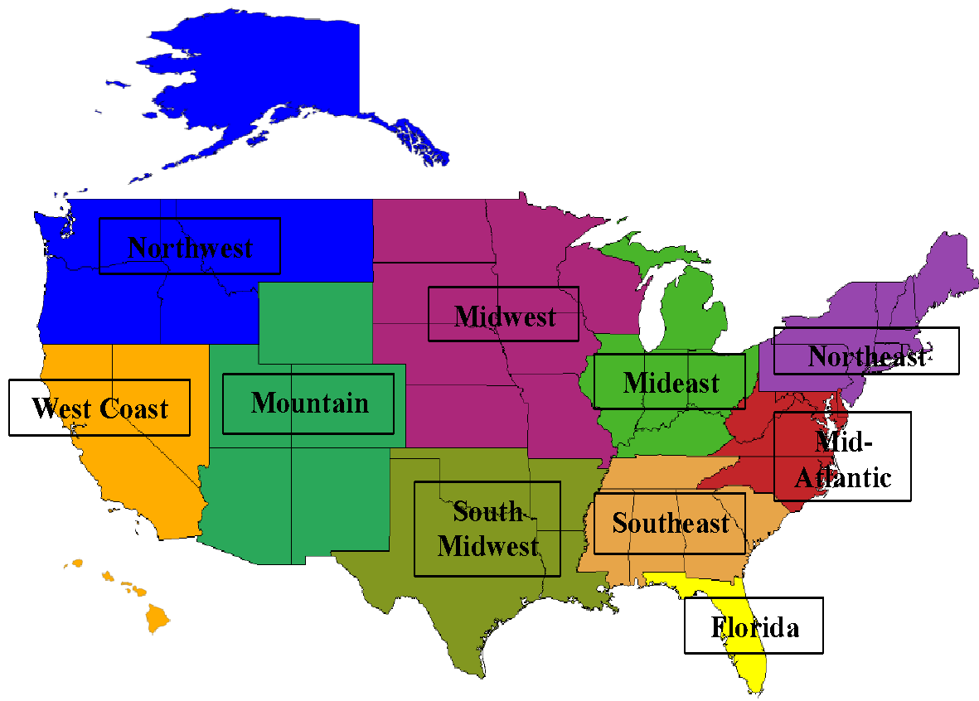
    - Each Conference Commissioner shall conduct a conference meeting at least annually to discuss the issues of his/her conference, as well as to schedule the upcoming official race season.
    - Three weeks written notice shall be given to each club in the Conference prior to the meeting.
    - Clubs shall request to place items for discussion on the agenda no later than five days prior to the scheduled meeting.
    - The agenda shall be distributed to all Club Reps no later than five days prior to the meeting.
    - Minutes from conference meetings shall be sent out to all Club Reps no later than 10 days after conference meetings.
  - There shall be no annual fee for membership in a Conference.

  - Collegiate Clubs
    - To participate and score within Collegiate Triathlon events a Club must be:
      - Officially recognized and be in good standing with its school to participate both at Conference events and at the National Club Collegiate Championship.
      - A member in good standing in its Conference, having submitted all proper paperwork, club roster and communications with the Conference Commissioner and USAT staff.
      - Registered as a USA Triathlon Club in good standing, having submitted the appropriate application and club fee to USA Triathlon.
    - Schools that have more than one geographically separate and distinct campus, each of which grants a separate degree or has a separate and distinct athletic department, must develop a separate club for each such campus location.
    - For purposes of Collegiate Triathlon and USAT record keeping, each club’s name will be the name of the club’s school, as recorded in IPEDS (http://nces.ed.gov/ipeds/).

  - Collegiate Athletes
    - To participate as a collegiate athlete within Collegiate Triathlon events, an athlete must meet all of the following requirements at the time of competition:
      - Be a full-time student in good standing at the school that will grant their degree, as defined by the Bursar, or Office of the Registrar at that school.
      - Be a member in good standing with a Collegiate Club as defined by Section 3.5
      - Be a member in good standing with USA Triathlon and Collegiate Triathlon
      - Be an annual member of USA Triathlon.
    - Athletes who are enrolled full-time during the fall/winter and complete their degree requirements for an advanced degree or are completing their degree in the spring, are eligible to compete in collegiate events held in the spring of the same academic year.
    - Athletes cannot race for two institutions in the same racing season unless an athlete academically transfers to a different institution. If an Athlete has changed Clubs (through transfer or after graduation) they must compete for the club in which they are currently enrolled as a full-time student and that club must meet the requirement set forth in Section 3.5 of these Rules.
    - No school or club may develop eligibility requirements that unduly hamper or deny any student from participating as an athlete for such club when the student otherwise satisfies the eligibility requirements of these Collegiate Rules.
    - Full-time student athletes from a school that does not currently have a registered collegiate triathlon club will be permitted, at the discretion of the race director, to race in conference collegiate competitions as “unaffiliated”, but will not be able to earn conference rankings or points and will not qualify for participation in Collegiate Club National Championships.
    - It is the athlete’s responsibility to ensure that they are registered under the appropriate collegiate club in the athlete’s online profile with USAT.
    - Current and former Elite and Collegiate Elite triathletes, who otherwise satisfy the eligibility requirements of these Collegiate Club Rules, are allowed to compete in Collegiate Triathlon events.
    - International students, who otherwise satisfy all of the eligibility requirements of these Rules, are allowed to compete in Collegiate Triathlon events, including the annual Collegiate Club National Championships.

- Petitions and Rulings. The CC may provide interpretations and clarifications to the collegiate competitive rules, but may not grant exceptions to any adopted rule or effectively change a rule without prior Board approval or unless expressly allowed herein.
  - Any collegiate athlete or club who wishes to be provided with an interpretation or clarification of any of the collegiate competitive rules must submit a petition to their Conference Commissioner. All petitions submitted by individuals or clubs must come from the club’s designated Club Rep.
  - The Collegiate Commissioner will forward all petitions to the Chair for a consideration of merits of the petition and, if warranted, subsequent discussion by the CC.
  - The complete petition must contain all of the following information:
    - All information relevant to the requested petition;
    - The name, telephone number and e-mail address of the petitioner;
    - The appropriate Club Rep of the athletic, club sports, or student club department that is responsible for supervising the athlete’s club;
    - All petitions will be reviewed by the CC and will be resolved within 30 days if the petition is determined to be complete and no additional information is required.
  - Decisions of the CC may be subject to review by the Board at the discretion of the Board. They may be appealed to the USAT Board of Hearings and Appeals as outlined in the USAT Competitive Rules, Article XI.
    - An appeal should not be filed with the USAT Board of Hearings and Appeals until the petition has first been reviewed by the CC.
    - Decisions made by the USAT Board of Hearings and Appeals are final and there shall be no further appeals.

- Collegiate Club Competitive Rules
  - General
    - In order to participate in Collegiate Triathlon events, an athlete must meet the athlete eligibility requirements of Section 3.6 and Collegiate Clubs must fulfill the requirements of Section 3.5. Proof of eligibility criteria must be furnished to USAT and the collegiate committee upon request.
    - In addition to these Rules, Collegiate Triathlon races must follow the competitive racing rules and regulations of USA Triathlon. It is each athlete’s responsibility to understand USA Triathlon Competitive Rules and the specific Rules applicable to Collegiate Triathlon. Any individual in violation of the Competitive Rules is subject to a variable time penalty or disqualification.
    - Collegiate athletes may not accept individual cash prizes at Collegiate Triathlon races or events. Cash awards may only be payable to an entire club. However, individual athletes at Collegiate Triathlon events may accept a merchandise awards.

  - Club Uniform
    - All athletes racing on behalf of their club must wear an official club uniform from the start to finish of the race.
    - The school’s name, nickname, or initials must appear on the club’s uniform and must be the largest and most prominent lettering or image on the uniform.
    - Uniforms may be unzipped during competition; however the school’s name or initials must remain prominently displayed on the front and back of torso.
    - Athletes who do not follow these standards during a race will receive a variable time penalty as defined in Section 3.7 of USAT Competitive Rules.
    - For Draft-Legal individual events, athletes must additionally follow the uniform guidelines of USAT competitive rules for draft-legal events.

  - Conference Events
    - The racing season for each Conference begins immediately after Nationals and concludes with Nationals of the following year.
    - The Conference racing schedule is organized by the Conference Commissioner and must be approved by a majority of the Club Reps within a conference.
    - All Conference events must be sanctioned by USA Triathlon to be eligible for inclusion in Conference Omnium scoring.
    - Conference events must include at least two of the following disciplines: swimming, cycling, or running.
    - The total distance covered by athletes in each discipline must lie within the following ranges: Swim: 0.4 – 2 km. Bike: 10 – 50 km. Run: 2 – 13 km.

  - Conference Omnium Scoring
    - Each Conference shall develop an Omnium scoring system that uses the following as a minimum guideline. The Omnium rules must be approved by majority vote of the Club Reps within the conference before the first scheduled conference event.
    - Individual Omnium Points at each Conference event are awarded separately to male and female athletes on a linear scale according to the following formula Points $=101-Place$ with a minimum score of (1) for any finisher. The scoring of the women’s and men’s races will be separate, so both the first placed woman and the first placed man will earn 1st place points.
Place | Points
1st | 100
2nd | 99
3rd | 98
10th | 91
99th | 2
100st | 1
    - Men/Women Club Score at conference events is determined by adding up a club’s respective top (4) male/female Individual Omnium Points for the race. In case of a points tie, the club with the most points from their 1st placed male/female will win.
    - Overall Club placing at conference events is determined by adding up the Men and Women Club Score. In case of a points tie, the club with the most points from their 1st placed male and female will win. If still tied, the combined scores of the progressively lower ranked (2nd then 3rd…) placed male & female will be used.
    - Club Omnium Points at each Conference event are awarded on a linear scale according to the following formula $Points=110-Place*10$ with a minimum score of 0.
Place | Points
1st | 100
2nd | 90
3rd | 80
10th | 10
    - Draft-legal conference races will award Individual Omnium points, but will not award Club Omnium Points unless the race is held in conjunction with a non-drafting conference event. In that case, Club place for the combined event is determined by adding the top (4) male and (4) female Points from the non-drafting race with the top (1) male and (1) female Points from the draft-legal race.
    - Each conference is required to hold an annual Conference Championship race.
    - Individual and Club Ominium points are doubled for the Conference Championship race.
    - Final Individual and Club Omnium Standings are determined by summation of points earned throughout the racing season. Conference Omnium rules may dictate that only a chosen subset of points will count towards final standings. (Default: Best scores from (#_{Races}/2 rounding down) races plus conference championship points)
    - If there is a tie in final Individual/Club Omnium points, the individual/club with the better placing at conference championship will be ranked higher in final Omnium.
    - Conference Commissioners will compile and certify the final Individual and Club Omnium Standings 2 weeks prior to the date of Collegiate Club Nationals.
    - Collegiate Club Nationals will not factor into Conference Omnium standings.

  - Collegiate Club National Championship Eligibility
    - To race at Collegiate Club Nationals, clubs must fulfill the club requirements of Section 3.5 and their athletes must meet the athlete eligibility requirements of Section 3.6 on the day of the championship event.
    - A club or their designated Club Rep must provide proof of eligibility (student ID and transcript, letter from the Office of the Registrar, etc.) for all student-athletes racing in the Collegiate Club National Championships for that school.
    - Unless granted an exemption from their respective Conference Commissioner, athletes must compete in one Conference Event in the season before racing Nationals.
      - Athletes participating in a study abroad program and unable to compete in the minimum conference race (1) requirement must submit a program transcript for confirmation of program participation. This must be submitted to the conference commissioner and passed by the Collegiate Committee as an exemption for Collegiate Club National Championship eligibility.
    - Collegiate athletes can race at Collegiate Club National Championships up to and including 6 times.

  - The Collegiate Club National Championships will consist of the following events:
    - Draft-Legal Sprint
      - Sprint to Olympic distance draft-legal event (750-1500 meter swim / 20-40km bike / 5-10km run)
      - Maximum of 2 men and 2 women entrants per Club.
      - Conducted in accordance with USAT competitive rules for draft-legal events
      - Athletes must races on compliant road bicycles for draft-legal events as outlined in USAT rules
    - Olympic
      - Olympic distance non-drafting triathlon with multiple waves.
      - No maximum number of entrants per Club if transition area space permits.
      - Conducted in accordance with USAT competitive rules for non-elite events.
      - Athletes must race on a traditional road or triathlon bicycle. Mountain bikes, hybrids and cruisers are not permitted.
    - Mixed Team Relay
      - Draft-legal team relay event where each competitor in a club of 2 men and 2 women completes a (250-300 meter swim / 5-8km bike / 1.5-2km run) triathlon then tags clubmate.
      - Maximum of 2 relay clubs per Collegiate Club.
      - Conducted in accordance with USAT competitive rules for draft-legal club relay events.
      - Athletes must races on compliant road bicycles for draft-legal triathlon as outlined in USAT rules
    - Paratriathlon Open
      - The event location and course availability will dictate whether a Paratriathlon Open wave can be safely offered. All best attempts will be made to have this option available.

  - Draft-Legal Sprint Qualification
    - Men/Women Conference Size is defined as the number of clubs from that conference that competed in the previous year’s Collegiate Club Nationals with four (4) Olympic finishers .
    - Allocation of starting spots is handled separately for the Men’s and Women’s event depending on the respective Men’s and Women’s conference size and Omnium.
    - Where applicable, fractional allocations are rounded to the nearest whole number.
    - Placement into the Collegiate Draft-Legal race is awarded to Clubs through qualification in conference competition.
      - Each conference is allocated a percentage of Collegiate Draft-Legal starting spots proportionally according to Men/Women Conference Size.
      - For a conference allocated N_{DL} spots, the top N_{DL} athletes in the conference Men/Women Individual Omnium Standings will earn their club a Collegiate Draft-Legal spot.
      - Clubs can earn a maximum of 2 spots, so if necessary, spots will roll down to the next best placed athletes. Should there be remaining starting spots left to fill the field; clubs will be granted an exception to exceed 2 per gender based on conference standings. A wait list will be maintained by the Collegiate Committee for allocation of remaining starting spots.
      - Clubs are not required to grant a spot to the athlete that actually earned the spot and may develop their own selection criteria.
    - Any current USAT elite athlete may request, at the discretion of the Collegiate Committee Chair, placement into the Collegiate Draft-Legal race if their club hasn’t otherwise been awarded Collegiate Draft-Legal spots.
    - Conferences who do not plan on using their entire allocation for the race may return their spots to be re-allocated at the discretion of the Collegiate Committee Chair.
  - Olympic Wave Seeding
    - Athletes competing in the Olympic race will be seeded in waves according to rankings provided by their Club to their respective commissioners by the earlier of two weeks from their Conference Championship or one week prior to the start of Collegiate Club Nationals.
    - Men/Women Conference Size is defined as the number of clubs from that conference that competed in the previous year’s Collegiate Nationals with four (4) Olympic finishers .
    - Allocation of Wave 1 spots is handled separately for the Men’s and Women’s event depending on the respective Men’s and Women’s conference size and Omnium.
    - Where applicable, fractional allocations are rounded to the nearest whole number.
    - 80% of Wave 1 slots are awarded through qualification in conference competition.
      - Each conference is allocated a percentage of Men/Women Wave 1 starting spots proportionally according to Men/Women Conference Size.
      - For a conference allocated N_{W1} spots, the top (N_{W1}*0.4) clubs in the conference Men/Women Club Omnium Standings will earn (2) Wave 1 spots.
      - A conference’s remaining Wave 1 spots are awarded to the top athletes in the conference Men/Women Individual Omnium Standings, excluding the top (2) athletes from a club that has already earned allocation through Club Omnium, will earn their club a Wave 1 spot.
      - Clubs can earn a maximum of 4 Wave 1 spots, so if necessary, spots will roll down to the next best placed athletes in Individual Omnium.
      - Clubs are not required to grant a Wave 1 spot to the athlete that actually earned the spot and may develop their own selection criteria.
    - 20% of Wave 1 slots are awarded through a national at-large pool
      - To be assigned to athletes not awarded a conference Wave 1 slot and will be based on finishing place at the previous year’s Collegiate Club Nationals.
      - There shall be no restriction on slots assigned to a single team.
    - Any current USAT elite athlete may request, at the discretion of the Collegiate Committee Chair, placement into Wave 1 if they have not otherwise been awarded Wave 1 spots.

  - Mixed Team Relay Qualification
    - Overall Conference Size is defined as the number of clubs from that conference that competed in the previous year’s Collegiate Club Nationals with four (4) Olympic finishers
    - Placement into the Collegiate Club Relay race is awarded to Clubs through qualification in conference competition.
      - Each conference is allocated a percentage of Collegiate Club Relay starting spots proportionally according to Overall Conference Size.
      - For a conference allocated N_{TR} spots, the top N_{TR} clubs in the conference Overall Club Omnium Standings will earn a Collegiate Club Relay Spot.
      - Relay clubs consist of 2 men and 2 women from the same Collegiate Club.
      - Clubs are not required to grant spots on the relay club to the athletes that actually earned the spots and may develop their own selection criteria.
    - Conferences who do not plan on using their entire allocation for the race may return their spots to be re-allocated at the discretion of the Collegiate Committee Chair.

  - Summary of Qualification Criteria
Race | Criteria | Selection
Draft-Legal Sprint | Men/Women Individual Omnium | - Top Individuals  - Max 2 per club
Olympic Wave 1 | Men/Women Club Omnium  &  Men/Women Individual Omnium | - 80% of Spots to top Clubs  - 20% of Spots to top Individuals  - Max 4 per club
Mixed Team Relay | Overall Club Omnium | - Top Clubs  - Max 2 clubs

  - Collegiate Club Nationals Scoring
    - Finishers in the Olympic race will earn points on a linear scale depending on their official place in the race according to the following formula $Points=501-Place$ with a minimum score of 1 for any finisher. Racers that do not finish will not earn points.
Place | Points
1st | 500
2nd | 499
3rd | 498
10th | 491
500th | 1
501st | 1

    - Finishers in the Collegiate Draft Legal race will earn points on a linear scale depending on their official place in the race according to the following formula $Points=102-(2*Place)$ with a minimum score of 2 for any finisher. Racers that do not finish, including being lapped out on the bike course, will not earn points.
Place | Points
1st | 100
2nd | 98
3rd | 96
10th | 82
50th | 2
51st | 2

    - The scoring of the women’s and men’s races will be separate, so both the first placed woman and the first placed man will earn 1st place points.

  - Collegiate Club Nationals Individual Awards
    - Top 3 Male & Female finishers in the Collegiate Draft Legal race will honored at awards ceremony
    - Top 5 Male & Female finishers in the Collegiate Olympic race will honored at awards ceremony
    - Collegiate Combined Champion Male & Female will be determined by adding up points from the Collegiate Draft Legal and Olympic races. In case of a tie, the best placed finisher in the Olympic race will win.

  - Collegiate Club Nationals Club Awards
    - Women’s Club Score will be determined by adding the top scores from up to (4) four finishers from the Olympic Non-Draft and the top (1) one finisher from the Draft-Legal race The highest Women’s Club score will win the Women’s Club Competition. In case of a points tie, the club with the best-placed female finisher in the Olympic race will win.
    - Men’s Club Score will be determined by adding the top scores from up to (4) four finishers from the Olympic Non-Draft and the top (1) one finisher from the Draft-Legal race l. The highest Men’s Club score will win the Men’s Club Competition. In case of a points tie, the club with the best-placed male finisher in the Olympic race will win.
    - If granted qualification from their conference, athletes may race in both the Olympic and Collegiate Draft Legal race and their scores from both races may be used to construct a Women’s/Men’s Club Score.
    - To encourage clubs to educate their athletes of the USAT competitive rules, if the top (7) Women/Men finishers from their club in the Olympic race are assessed (3) or more variable time penalties, their respective Women’s/Men’s Club Score will be assessed an additional (-500) point penalty.
    - Overall Club Score will be determined by adding the Women’s Club Score with the Men’s Club Score. In case of a points tie, the club with the most points from their 1st placed male & female combined will win. If still tied, the combined scores of the progressively lower ranked (2nd then 3rd…) placed male & female will be used.
    - Top 3 finishers from Collegiate Club Relay race will be honored at awards ceremony but will not factor into the Overall Club Score.

  - Summary of Collegiate Club Nationals Awards
Race | Award | Calculation
Draft Legal Sprint | Top 3 Individual (Male and Female) | Finishing Place
Olympic | Top 5 Individuals (Male and Female) | Finishing Place
Combined Champion | Top 1 Individual  (Male and Female) | Summation of Olympic and Draft Legal points
Men’s Club | Top 5 Clubs | Top 4 points from Olympic and Top 1 points from Collegiate Draft Legal
Women’s Club | Top 5 Clubs | Top 4 points from Olympic and Top 1 points from Collegiate Draft Legal
Overall Club | Top 5 Clubs | Summation of the Male and Female club scores
Mixed Team Relay | Top 3 Clubs | Finishing Place

